Name: _________________________________ Period: _______ Date: _____________

Separation of Mixtures

Separation Technique | Separates What From What? | How It Works | Example
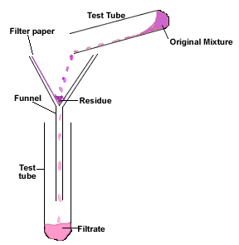
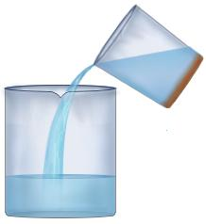
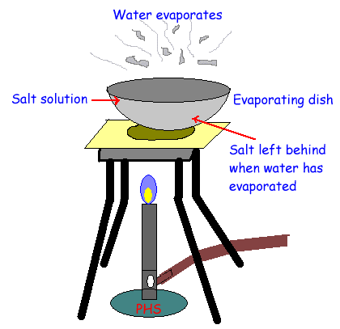
Separation Technique | Separates What From What? | How It Works | Example
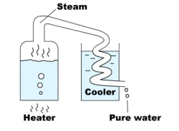
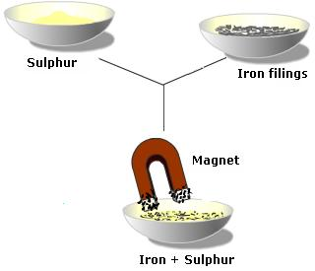
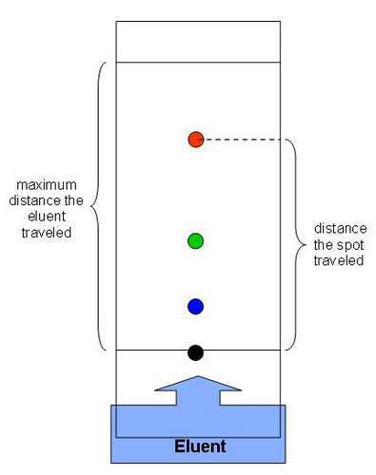

Separation of Mixtures Practice Problems

1. Name the techniques that are suitable for separating the following mixture:
Situation | Separation Technique
- To obtain drinking water from muddy water
- To remove leaves from a swimming pool
- To obtain pure sugar from a solution
- To determine whether the coloring in a fruit juice is a single substance or a mixture of colored substances

2. You are asked to separate sand and salt (NaCl). Name the methods needed to carry out the procedure. Explain how you would carry out the procedure to obtain pure sand and salt (NaCl) back.
________________________________________________________________________
________________________________________________________________________
________________________________________________________________________
________________________________________________________________________

3. Ms. Eggleston needs to use distillation to separate a mixture of three liquids. Liquid A has a boiling point of 60 degrees Celsius, Liquid B has a boiling point of 50 degrees Celsius, and Liquid C has a boiling point of 100 degrees Celsius.

Liquid | Boiling Point (in degrees Celsius) | a. First, copy the boiling point of each liquid into the chart below.  b. When Ms. Eggleston heats a beaker of the mixture, which compound will be separated first?  c. Liquid ___________ (A, B, or C) will be separated first.  d. How do you KNOW? Explain your answer for part c.  __________________________________________________  __________________________________________________
A
B
C

