Name: ___________________________________ Period: _________ Date: ___________________

Chemical and Physical Changes

Chemical Change | Physical Change
Definition: | Definition:
Examples: | Examples:
CLUES:
How can I recognize a physical or chemical change?
1. | 1.  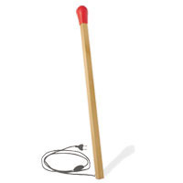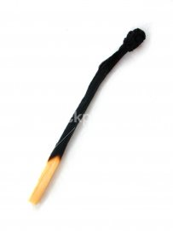
2. | 2.  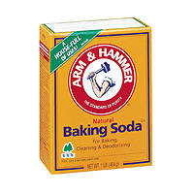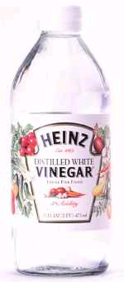
3. | 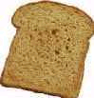  3.
4. | 4.  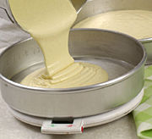
5.  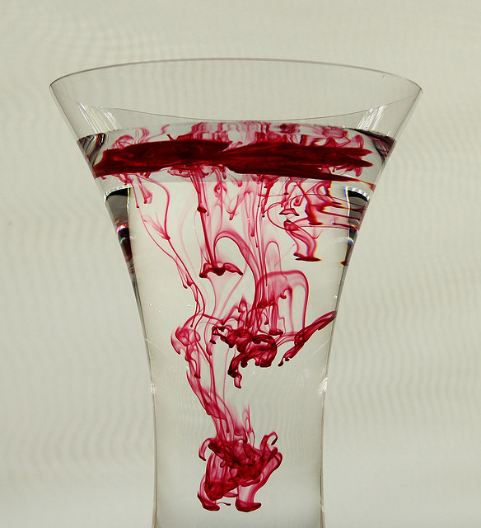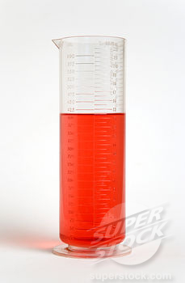 | 5.  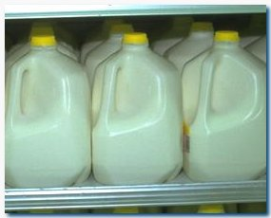  1 month old
 | 6.

Chemical and Physical Changes Lab

INFORMATION TABLE:
Station 1. Hydrochloric acid and Magnesium | Station 2. Magnesium sulfate and water | Station 3. Calcium carbonate | Station 4. Food coloring | Station 5. Starch and iodine
Materials:  - Small strip of Magnesium  - Plastic pipette  - Rubber Gloves  - Test Tube  - Hydrochloric acid | Materials:  - Beaker with water  - Test tube  - Water  - Magnesium sulfate  - Scoopula | Materials  - Stick of Calcium carbonate  - Mortar and pestle | Materials  - Three test tubes  - Water  - Stirring rod  - Food coloring | Materials  - Test tube  - Iodine  - Cornstarch solution  - 2 plastic pipettes  - Scoopula
Warnings:  You must wear gloves when working with HCl.  Skin Contact: Immediately flush skin with plenty of water for at least 15 minutes while removing contaminated clothing and shoes. Get medical attention immediately. Wash clothing before reuse. Thoroughly clean shoes before reuse.  Eye Contact: Immediately flush eyes with plenty of water for at least 15 minutes, lifting lower and upper eyelids occasionally. Get medical attention immediately. | Warnings:  Magnesium sulfate harmful if swallowed. | Warnings  Calcium carbonate is dangerous if ingested. | Warnings  Don't drop the food coloring on the desk or your clothes – it can stain them permanently. | Warnings  - Iodine is dangerous if swallowed.  - Never consume food in the lab.
Procedure:  - Use the plastic pipette to transfer approximately 50 ml (a few centimeters) HCl into the test tube  - Drop the strip of Magnesium into test tube with HCl  - Observe. | Procedure:  - Use the scoopula to add a small amount of Magnesium sulfate to the test tube  - Add water until the test tube is 1/3 full  - Use the scoopula to stir vigorously  - Stir until all the Magnesium sulfate is dissolved | Procedure:  - Observe the Calcium carbonate and write your description below  - Place a stick of Calcium carbonate into the mortar and pestle (2-3 cm)  - Use the pestle to grind the particles until they are dust  - Observe | Procedure:  - Fill two test tubes halfway with water  - Add one drop of food coloring to each beaker (different colors)  - Pour both test tubes into the third test tube | Procedure:  - Use a plastic pipette to place a small amount of cornstarch solution into the test tube  - Use the other plastic pipette to drop 3 drops of iodine into the test tube  - Observe all changes and write descriptions below

Data Table
Station | Observations | Hypothesis: Chemical or Physical Change? | Reasons for Hypothesis: Must have SEVERAL clues from today’s list of physical/chemical changes
1. Hydrochloric acid and Magnesium
2. Magnesium sulfate and water
3. Calcium carbonate
4. Food coloring
5. Starch and iodine

Chemical or Physical Change Practice

Directions: Indicate physical change with a “P” and chemical change with a “C.” In the 3rd column, write down the clues that helped you decide whether the change was chemical or physical.

Example | Chemical or Physical? | Clues (Look in Today’s Notes)
Glass breaking
Hammering wood together
A rusting bicycle
Melting butter
Separate sand from gravel
Bleaching your hair
Frying an egg
Squeeze oranges for juice
Melting ice
Mixing salt and water
Mixing oil and water
Water evaporating

Name: ________________________________ Period: __________ Date: ____________

Exit Ticket

1. Classify each of the following as a physical or chemical change. Place an X in either the physical or chemical change column. For any chemical change, list at least one clue to support your answer.
Example | Physical Change | Chemical Change | List one clue to support your answer if you chose “Chemical Change”
A copper wire is burnt

Charcoal burns in a grill
Cracking an eggshell

Sugar dissolves in water

Name: ________________________________ Period: __________ Date: ____________

Exit Ticket

1. Classify each of the following as a physical or chemical change. Place an X in either the physical or chemical change column. For any chemical change, list at least one clue to support your answer.
Example | Physical Change | Chemical Change | List one clue to support your answer if you chose “Chemical Change”
A copper wire is burnt

Charcoal burns in a grill
Cracking an eggshell

Sugar dissolves in water

