Name: _________________________________ Period: _______ Date: _____________

Matter HW

Categorize each diagram below as an element, compound, mixture of elements, mixture of compounds, or mixtures of elements and compounds.
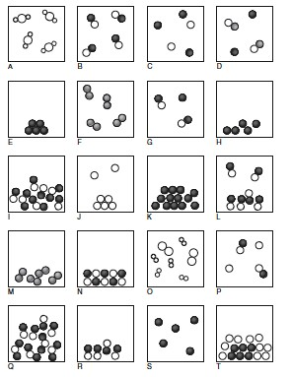
A: __________________________
B: __________________________
C: __________________________
D: __________________________
E: __________________________
F: __________________________
G: __________________________
H: __________________________
I: __________________________
J: __________________________
K: __________________________
L: __________________________
M: __________________________
N: __________________________
O: __________________________
P: __________________________
Q: __________________________
R: __________________________
S: __________________________
T: __________________________

Categorize each diagram as a solid, liquid, or gas. Write the letter of each diagram in one of the boxes below.
Solids | Liquids | Gases

Graduated Cylinders

Read each graduated cylinder and write the amount. Be sure to include mL in your answer.

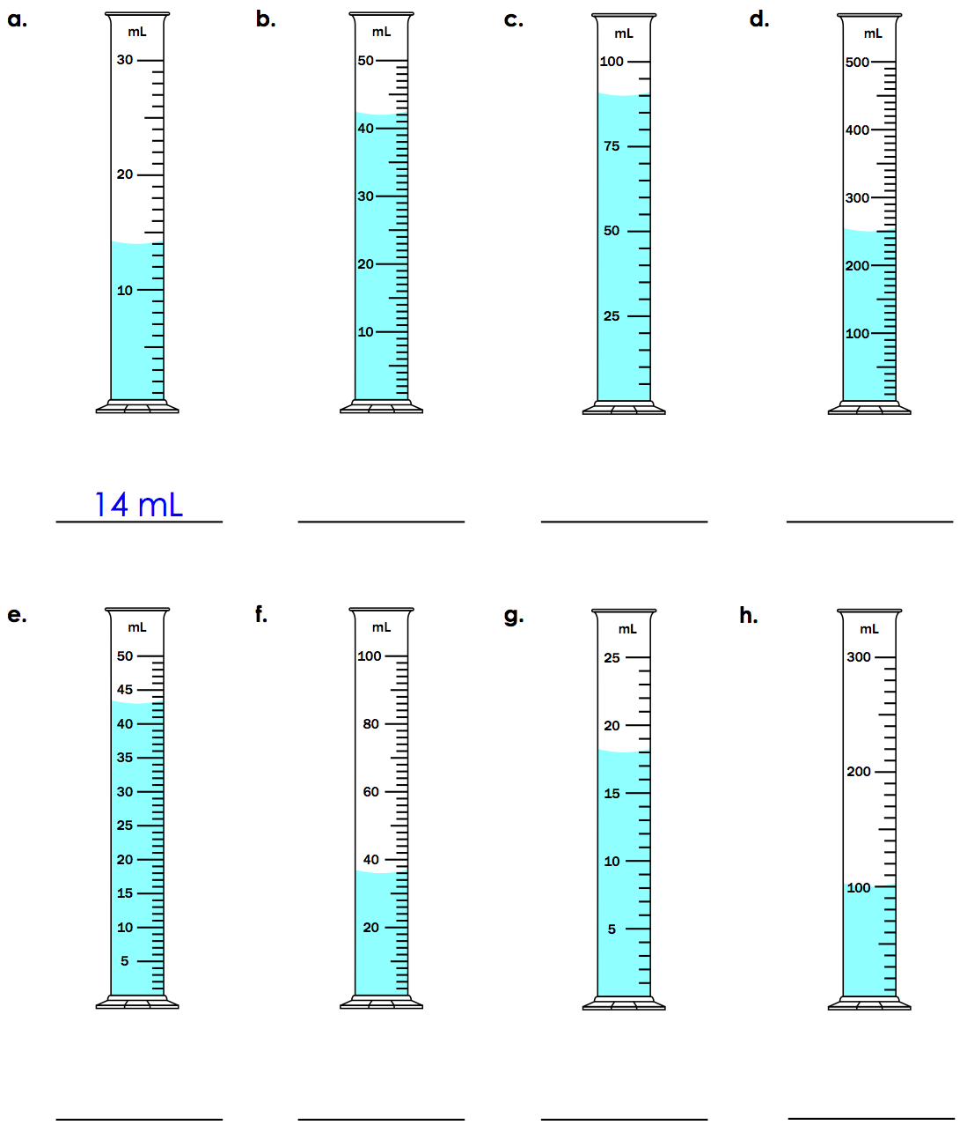

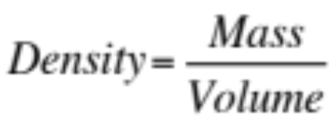

1. A block of aluminum occupies a volume of 15 mL and has a mass of 40.5 g. What is its density?

2. Mercury metal is poured into a graduated cylinder that holds exactly 22.5 mL. The mercury has a mass of 306 g. From this information, calculate the density of mercury.

4. A rectangular block of copper metal weighs 1896 g. The dimensions of the block are 8.4 cm by 5.5 cm by 4.6 cm. From this data, what is the density of copper?

5. What is the volume of a silver brick with a mass of 2500 g? The density of silver is 10.5 g/cm³.

6. Find the mass of 250 mL of benzene. The density of benzene is 0.8765 g/mL.

7. A block of lead has dimensions of 4.50 cm by 5.20 cm by 6.00 cm. The block weighs 1587 g. From this information, calculate the density of lead.

