Name: _________________________________ Period: _______ Date: _____________

States of Matter Practice Problems

Matching
Match the State of Matter with the correct description.
1. SOLID a. No definite shape or volume
2. LIQUID b. Definite shape and volume
3. GAS c. Definite volume but no definite shape
4. SOLID a. Particles are packed close together and do not move
5. LIQUID b. Particles are free to move and spread out to fill their
container
6. GAS c. Particles are close together but free to move

Changes in States of Matter
7. What happens to the speed of the molecules as you move from a solid to a liquid to a gas?

8. What happens to the speed of the molecules as you move from a gas to a liquid to a solid?

9. Angelica has a substance whose molecules are fixed in place and vibrate. Does she have a solid, liquid, or gas?

10. Angelica heats the substance. What happens to the speed of the molecules?

11. Angelica heats the substance so much that it changes to a new state. What state of matter is it now – solid, liquid, or gas?

PHYSCIAL AND CHEMICAL CHANGES

Classify the following changes as being a physical change or a chemical change by putting a check in the appropriate column.
 | Physical Property | Chemical Property
12. Salt dissolves in water
13. Water is heated and changed into steam
14. Iron rusts
15. Food is digested in the stomach
16. Ice melting

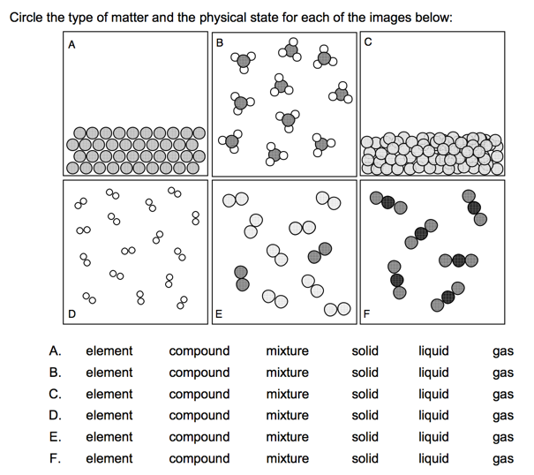

Directions: Column A lists a substance. In Column B, list whether the substance is an element (E), a compound (C), a Heterogeneous Mixture (HM), or a Solution (S). (Remember a solution is a homogeneous mixture.) In Column C, list TWO physical properties of the substance.

Column A | Column B | Column C
17. Summer Sausage
18. Steam
19. Salt Water
20. Pencil lead (Pb)
21. Dirt
22. Pepsi
23. Silver (Ag)
24. Toothpaste (Na₂HPO₄)
25. A burrito
26. Italian Dressing
27. Chicken Soup
28. Lemonade

