Name: _________________________________ Period: _______ Date: _____________

Atomic Basics Homework


Part A: Atomic Structure

1. Draw five protons in the nucleus of the atom. Label them with their charge.
2. Draw six neutrons in the nucleus of the atom.
3. Draw two electrons in the first energy level and label them with their charge.
4. Draw three electrons in the second energy level and label them with their charge.
5. What element is represented by the diagram? ____________

Part B: Atomic Calculations
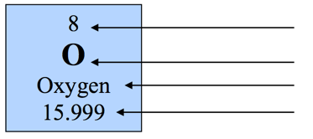
6. Label the information provided in the periodic table for oxygen.

7. What does the atomic number represent?

_____________________________________ or _____________________________________

8. What does the atomic mass represent?

____________________________ + _____________________________

9. How would you figure the number of protons or electrons in an atom?

10. How would you figure out the number of neutrons in an atom?

11. Use your knowledge of atomic calculations to complete the chart. DON’T look up the Atomic Mass in the Periodic Table. Calculate it using the other information given to you below.

Element | Atomic Number | Atomic Mass | Protons | Neutrons | Electrons
Li | 3 | 7
P | 15 | 31
Cl |  | 35 | 17
Ni | 28 |  |  | 31
K |  | 39 |  |  | 19
Ag | 47 |  |  | 61
H |  | 1 | 1
Si |  |  |  | 14 | 14
W |  |  | 74 | 110
Ne |  |  |  | 10 | 10

