Name: _________________________________ Period: _______ Date: _____________

Phase Change Notes

New Vocabulary | Explanation
Phase
Phase Change
Melting Point
Boiling Point
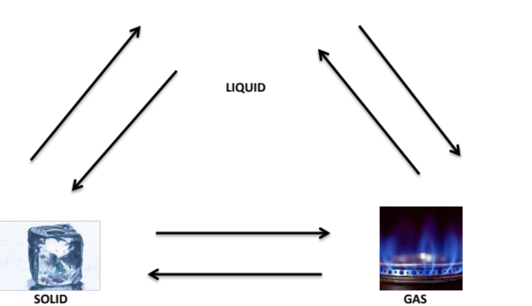
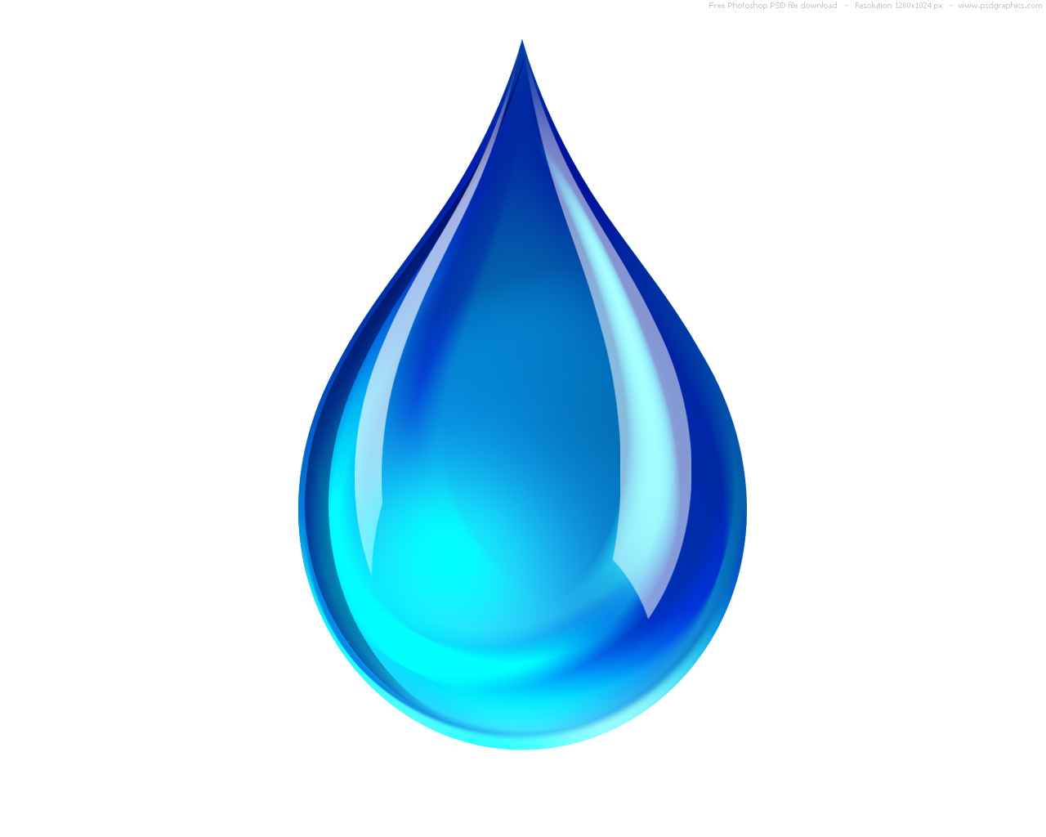
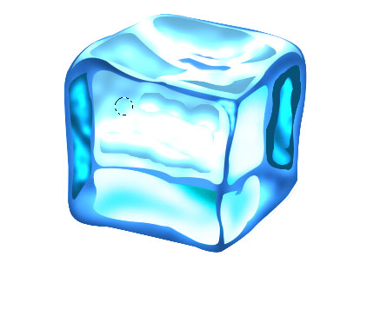
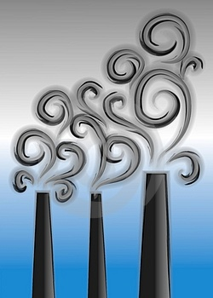
LIQUID
SOLID
GAS
Name: _________________________________ Period: _______ Date: _____________

Phase Change Practice Problems

- How does the amount of energy change as a solid is heated? ____________________________

- Which state of matter has a definite volume but not a definite shape? _____________________

- In which states of matter can materials take the shapes of their containers?
- ___________________ and ___________________
- Mike has a substance whose molecules are fixed in place and vibrate. Does he have a solid, liquid, or gas? ________________________
- Which set of properties does a substance such as carbon dioxide gas have?
  - definite shape and definite volume
  - definite shape but no definite volume
  - no definite shape but definite volume
  - no definite shape and no definite volume

- Which has the fastest moving particles?

- H₂O(g)
- H₂O(l)
- H₂O(s)
- NaOH(aq)

- Name the phase change happening in each of the following examples:
a. A block of ice turning into a liquid. ________________________________________
b. A pot of boiling water turning to steam. _____________________________________
c. Water forming on the grass in the early morning. ______________________________

- Use the following particle diagrams to answer the following questions.
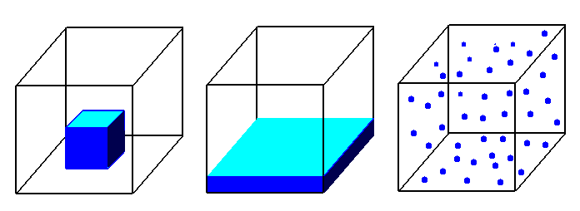
Figure 2
Figure 3
Figure 1

- Which set of particle diagrams is arranged in order of increasing energy?
  - 3, 2, 1
  - 2, 1, 3
  - 1, 2, 3
  - 3, 2, 1

