Name: _________________________________ Period: _______ Date: _____________

Unit 2 Review Problems

Hello my wonderful students,
I am out sick and will miss you very much today. In my absence, I’ve prepared a packet of review problems for you to work on. These problems are designed to help you study for your test next Wednesday. If you don’t finish the packet in class, you must complete it for homework. I will collect the packet from you on Thursday. Do NOT hand it in to the substitute teacher!
Good luck,
Ms. Eggleston

Classify each of the diagrams below by placing the correct label in the blanks below:

A = element
B = compound
C = mixture of elements
D = mixture of compounds
E = mixture of elements and compounds
a. ________________  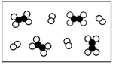 | b. ________________  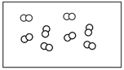 | c. ________________  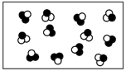
d. ________________  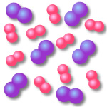 | e. ________________  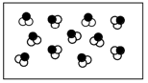 | f. ________________  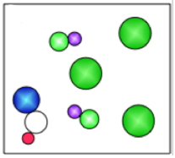

Classify each of the materials below. In the center column, state whether the material is a pure substance or a mixture. If the material is a pure substance, further classify it as either an element or compound in the right column. Similarly, if the material is a mixture, further classify it as homogeneous or heterogeneous in the right column. Write the entire word in each space to earn full credit.

Material | Pure Substance  or Mixture | Element, Compound,  Homogeneous, Heterogeneous
concrete
sugar + pure water
(C₁₂H₂₂O₁₁ + H₂O)
iron filings (Fe)
limestone (CaCO₃)
orange juice (w/pulp)
Pacific Ocean
air inside a balloon
aluminum (Al)
magnesium (Mg)
acetylene (C₂H₂)
tap water in a glass
soil
pure water (H₂O)
chromium (Cr)
Chex mix
salt + pure water
(NaCl + H₂O)
benzene (C₆H₆)
muddy water
brass
(Cu mixed with Zn)
baking soda (NaHCO₃)

Identify the following as being true or false to the left of the sentence.

_____ 1. A change in size or shape is a physical change.
_____ 2. A chemical change means a new substance with new properties was formed.
_____ 3. An example of a chemical change is when water freezes.
_____ 4. When platinum is heated, then cooled to its original state, we say this is a physical change.
_____ 5. When milk turns sour, this is a physical change because a change in odor does not indicate a chemical change.
_____ 6. When citric acid and baking soda mix, carbon dioxide is produced and the temperature decreases. This must be a chemical change.

Identify each of the following as an example of a physical property or a chemical property.

- Silver tarnishes when it comes in contact with hydrogen sulfide in the air.

- A sheet of copper can be pounded into a bowl.

- Gold melts at 725 C.

- Gasoline is flammable.

- A bar of lead is more easily bent than is a bar of aluminum of the same size.

- Potassium metal is kept submerged in oil to prevent contact with oxygen or water.

- A piece of charcoal, which is mostly the substance carbon, glows red, gives off heat, and becomes a gray ash.

- Oxygen is a gas

- Argon is not very reactive

- The piece of metal is magnetic

Density of Candy

Before calculating the densities of the various candy bars, answer the following questions:

- Predict what candy bar will have the highest density: __________________________

- Predict what candy bar will have the lowest density: ___________________________

Candy | Mass of Candy | Volume of Candy | Density of Candy
Snickers | 50 grams | 7 cm³ |  | 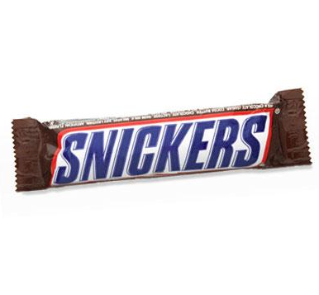
3 Musketeers | 15 grams |  | 5 g/cm³ | 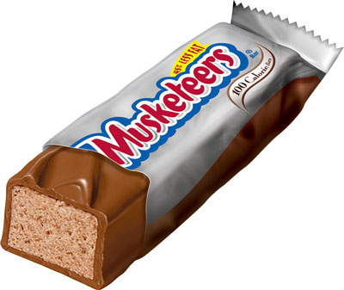
Kit Kat | 28 grams | 25 cm³ |  | 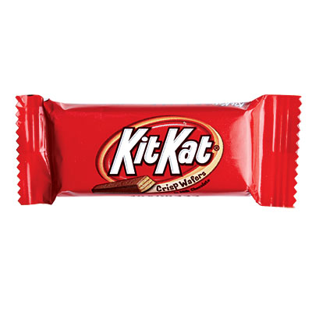
Twix |  | 3 cm³ | 6 g/cm³ | 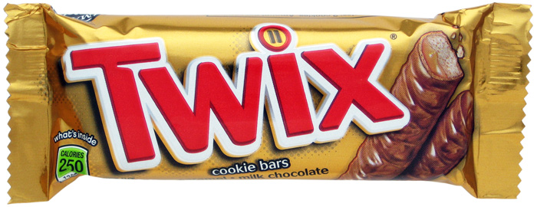
Milky Way | 37 grams | 17 cm³ |  | 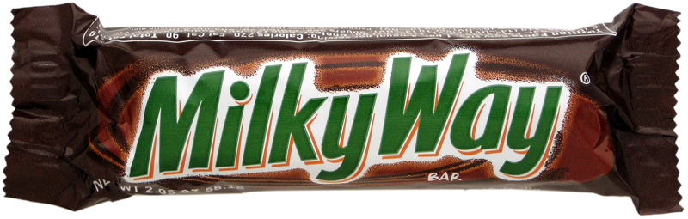
DATA TABLE

