Name: ____________________________________ Period: ________ Date: ________________
The Periodic Families

Alkali Metals
The Alkali Metals:
1. Which orbital (s, p, d, or f) are the Alkali metals in?

2. What about Alkali metals makes them behave like metals? What properties do they have?

3. Why do Alkali metals have to be kept in oil solutions?

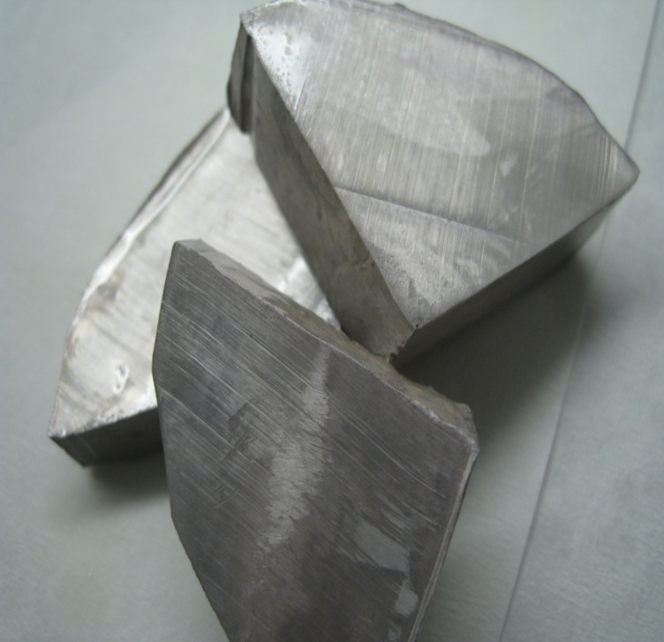

Halogens
Halogens:

1. Which group are the halogens in? How many electrons do they have in their last orbital?

2. Halogens are nonmetals. Which properties and characteristics do halogens have in common?

3. Based on the reading, what are some different states of matter that halogens can exist in?

4. Halogens can be toxic in large doses. Pick an element from the halogens list above. What is one way that element is used in our everyday life? Think of ways that the element can be potentially harmful and list them below:

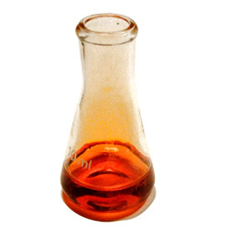

Noble Gases
Noble Gases:

1. Which group are the noble gases a part of? Draw the Bohr model of one below.

2. Do noble gases have the characteristics of nonmetals, metals, or metalloids? List at least one characteristic to support your answer.

3. Name one way that noble gases are used in everyday life. Don’t use the example in the reading. Look at the elements and think of your own!

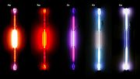

Alkaline Earth Metals
Alkaline Earth Metals:

1. Which group are the alkaline earth metals in? Are alkaline earth metals in the s, p, d, or f orbital?

2. Based on the reading and your knowledge of metals, what properties and characteristics do alkaline earth metals have in common?

3. As discussed in the reading, Alkaline earth metals have a strong presence in living organisms. Think of a specific alkaline earth metal and how it is important to your health and well being (Be specific!).

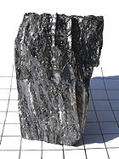

Transition Metals

1. Which groups contain the transition metals?

2. What are some properties that transition metals have?

3. Name one interesting fact about a particular transition metal (look at your periodic table and come up with your own example or use the example given in the reading).

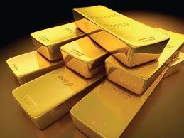

Comprehension Questions
Level 1

1. Which of the following is an alkali metal?

a. H c. Cl
b. Xe d. Cs

2. Which of the following is a noble gas?

a. Li c. Ar
b. Br d. F

3. Which of the following is a halogen?

a. I c. Na
b. K d. Ne

4. If you drop an element in water and it explodes, what family does it belong to?

a. Halogens c. Noble gases
b. Alkali metals d. Alkaline Earth metals

5. If you have an element that combines with alkali metals to make salts, what family does it belong to?

a. Alkali metals c. Salts
b. Halogens d. Noble gases

6. If you have an element that does nothing when mixed with other elements, what family does it belong to?

a. Noble gases c. Non-metals
b. Halogens d. Alkali metals

Level 2

1. If you discovered element number 118, which properties would you expect it to have? WHY?

2. Which element do you think Au (gold) acts like the most? Explain your answer.

a. Hg (mercury) c. Ag (silver)
b. Pt (platinum) d. Cd (cadmium)

3. Some alkali metals are stored in tubes of argon gas. Why would argon be a safe gas to store an alkali metal in?

4. Helium is hard to find on Earth because it is so light (atomic number = 2), so it floats away from the Earth. Hydrogen, however, is even lighter (atomic number = 1), but is one of the most common elements on Earth. Why doesn’t hydrogen float away like helium?

Properties of Periodic Families
Periodic Family | Group(s) | Example | Properties/Real Life Applications
Alkali metals
Alkaline earth metals
Transition metals
Halogens
Noble gases

Properties of Periodic Families
Periodic Family | Group(s) | Example | Properties/Real Life Applications
Alkali metals | 1 (except hydrogen) | Sodium | Reactive by themselves  Always found in a compound  Malleable  Ductile  Good conductors  Soft  Kept in oil to avoid chemical reactions  Can explode if exposed to water
Alkaline earth metals | 2 | Magnesium | Reactive  Sometimes shiny  High melting point  Withstand fires of earth’s core  Present in living organisms
Transition metals | 3-12 | Gold | D block  High conductivity  Malleable  Shiny  High melting and boiling points  Gold was one of the first metals discovered  Medieval chemists tried to turn other metals into gold (alchemy)
Halogens | 17 | Fluorine | Nonmetals  Reactive by themselves  Combine with alkali metals to make salts  Various states of matter  Harmful/deadly to humans
Noble gases | 18 | Helium | Colorless  Odorless  Nonreactive  Don’t form compounds  Boiling point and melting point low and close together  Many industrial uses  Krypton used in high powered gas lasers

Name: _____________________________ Period: _______ Date: ________________

Periodic Families Homework

- Which element is in group 4 period 5? _______
- How many elements are in period 4? ________
- How many elements are in period 6? ________
- How many metals are in group 14? _________

- The majority of the elements in the periodic table are (metals/nonmetals). (Circle one)
- The father of the periodic table is named __________________________________________.
- As you go from left to right across the periodic table, the elements go from (metals/nonmetals) to (metals/nonmetals). (Circle the answers)
- Element X has a metallic shine, is located in the 4th period, and is an alkaline earth metal. Which element is it? ____________________________
- Element Y is not shiny, has 6 protons, and is frequently called the “building block of life.” Which element is it? _____________________________
- Which of the following statements about metals is correct?
  - They are ductile but not shiny
  - They conduct electricity but are not ductile
  - They do not conduct electricity and are not shiny
  - They conduct electricity and are malleable
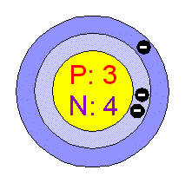
- The diagram below represents the Bohr model of an element. Which of the following is true?
  - The element is located in period 1 and is a group 2 metal
  - The element is located in period 1 and is an alkali metal
  - The element is located in period 2 and is an alkali metal
  - The element is located in period 2 and is a halogen
- Complete the table below:
Element | Properties | Real Name | Periodic Family
A | This metal reacts vigorously with water and it has 3 energy levels
B | This nonmetal is located in period 3 and is used to disinfect and kill bacteria in pools
C | Its outermost energy level is full and it has 22 neutrons
Periodic Table Vocabulary
Choose the correct words from the list, then place the appropriate number in each blank.
Word List:

- Alkali metals
- Alkaline earth metals
- Atomic mass
- Atomic number
- Family
- Group
- Halogens
- Metal
- Metalloids
- Noble gases
- Nonmetal
- Period
- Periodic law
- Periodic table
- Transition metals

Dmitri Mendeleev developed a chart of the elements called the . He said that if the elements were listed in order of increasing , their properties repeated in a regular manner. He called this the of the elements. The arrangement used today is different than Mendeleev’s because the elements are arranged in order of increasing . Each horizontal row of elements is called a . Each vertical column is called a ______, or , because of the similarities between elements in the same column, a _______.
In rows 4 through 7, there is a wide central section containing elements that are called . Each of the elements to the left of the staircase line of the chart, is classified as a . Each of the elements at the right side of the staircase line is classified as a . The elements between these two main types, with some properties of one type and other properties of the other type, are called . The elements in group 1 are called ______. The elements in group 2 are called . The elements in group 17 are called ________ and the elements in group 18 are called ________.

