Name: ________________________________ Period: _______ Date: _____________

HONORS HW: Due Friday, March 21

Welcome to the Snicker Bar Galaxy!

You have just entered a faraway galaxy where their unit of measurement is completely foreign to our system. You’ll need to think out of this world to find the answers to these problems!
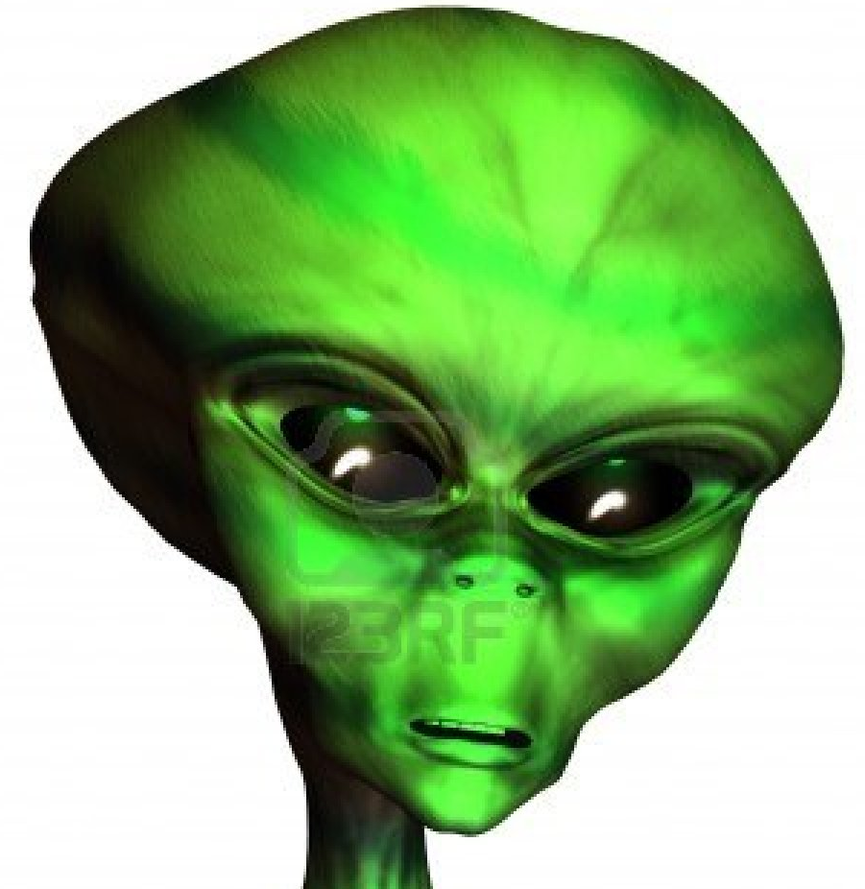
Conversion Factors:
1 wicket = 10 gidget
1 gidget = 5 wazoos
1 wazoo = 4 trifles
1 trifle = 2 bizbastics
1 bizbastic = 3 bamboo
1 bamboo = 8 gidgantics

Practice Problems:
1) How many wazoos are in 10 gidgets? | 5) How many gidgets are in 5 wickets?
2) How many trifles are in 8 bizbastics? | 6) If you have 2 wickets, how many wazoos do you have?
3) You have 3 bamboo. How many gidgantics do you have? | 7) If you have 4 trifles, how many bamboo do you have?
4) How many bizbastics are in 72 gidgantics? | 8) How many gidgets are in 40 wickets?

