Name: _________________________________ Period: _______ Date: _____________

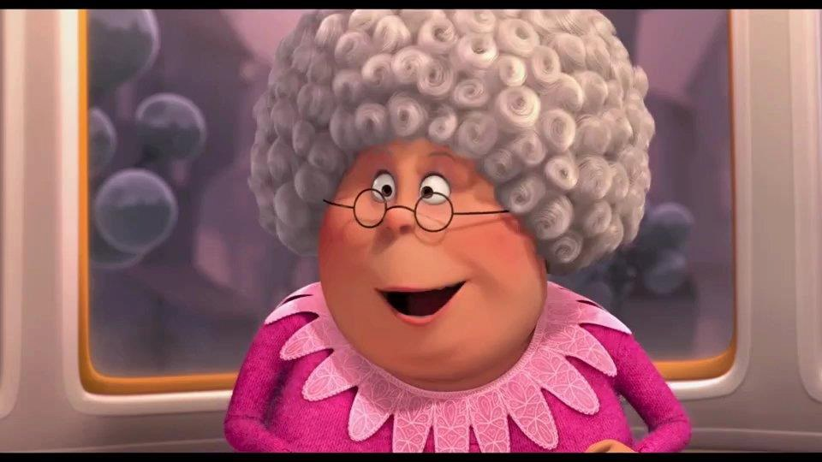
GRANDMA MOLE PRELAB
Standard
Introduction
Grandma Mole was a chemist and she kept all of her recipes in units of moles in order to keep them a family secret. In this lab you will need to convert her recipe with the chemical names into English units of measurement in order to be able to make and EAT a surprise treat.

Part 1: Molar Mass Calculations (You’ll need this for your calculations.)
Compound | Chemical Formula | Molar Mass (SHOW WORK)
Glucose | C₆H₁₂O₆
Salt | NaCl
Lactose | C₁₂H₂₂O₁₁
Vanillin | C₈H₈O₃

Part 2: Prelab Conversions
Use the given conversion factors below to find the actual recipe. Fill in the chart on the back with the actual measurements. Show all work and BOX your final answer.

1. 1.22 mol glucose _______ lb powdered sugar.
- 0.97g glucose = 1 g powdered sugar
- 453.5g powdered sugar = 1 lb powdered sugar

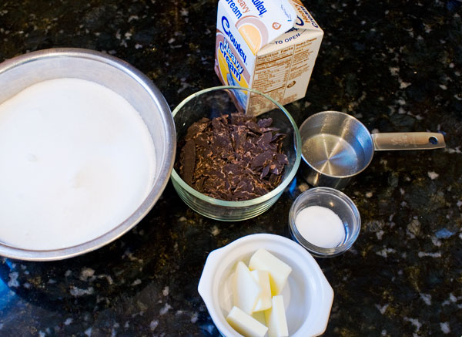
2. 3 tbsp mixed esters __________ tbsp butter
- 1 tbsp mixed esters = 1 tbsp butter

3. 0.002 moles benzoyl ecgoninex ______ cup cocoa
- 1 mole benzoyl ecgoninex = 209.3 g benzoyl ecgoninex
- 0.01 g benzoyl ecgoninex = 1 g cocoa
- 226 g cocoa = 1 cup cocoa

4. 0.00695 moles lactose __________ tbsp milk
- 0.0464 g lactose = 1 g milk
- 1.59 g milk = 1 mL milk
- 1 mL milk = 0.062 tbsp milk

5. 0.00239 moles vanillin __________ tsp vanilla
- 0.0275 g vanillin = 1 g vanilla
- 1.056 g vanilla = 1 mL vanilla
- 1 mL vanilla = 0.02 tsp vanilla

