
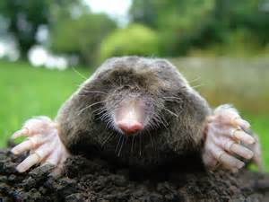

Name: ____________________________ Period: __________ Date: _____________

Introduction to the Mole

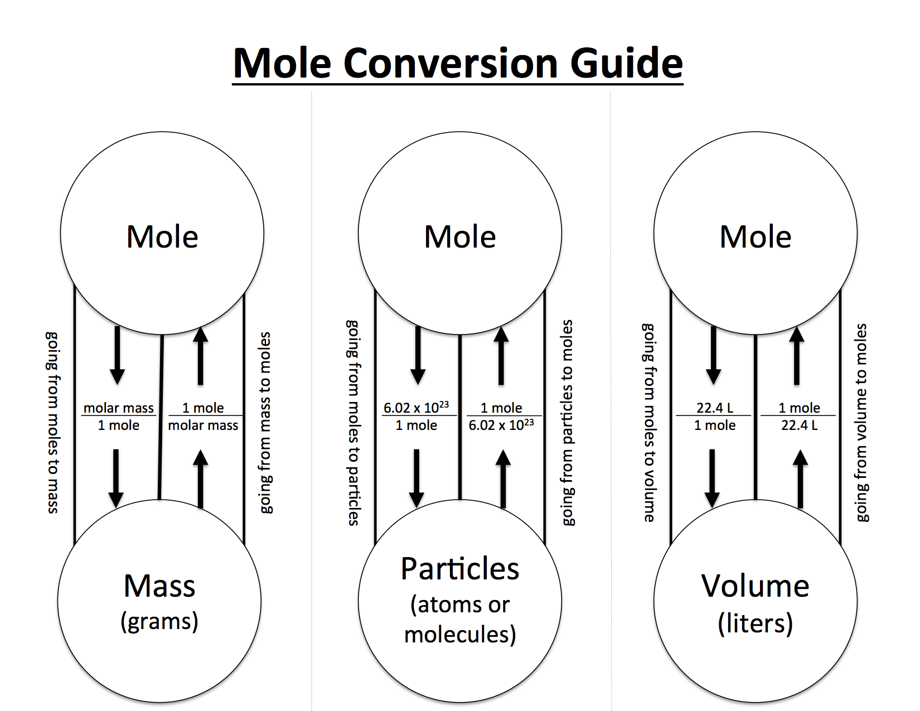
Part 1: Introduction to the Mole


New Unit: THE MOLE!

1 mole = _______________________ particles
- Avogadro’s number = ________________________________

Molar Mass (in grams): __________________________________________________________
______________________________________________________________________________
- Same as the ATOMIC MASS found in the PERIODIC TABLE

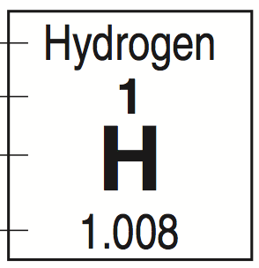

Molar mass

1 mole of Carbon = _____________ grams of carbon
1 mole of Nitrogen = _____________ grams of nitrogen
1 mole of Hydrogen = _____________ grams of hydrogen
1 mole of Copper = _____________ grams of copper
IF ASKED FOR # OF ATOMS, START WITH 1 MOLE = 6.022 x 10²³ ATOMS

IF ASKED FOR MASS OR GRAMS, LOOK UP MOLAR MASS IN PERIODIC TABLE

Hey! Call me sometime...my number is
6.02 x 10²³
1 mole of particles = 6.02 x 10²³ particles
Particle is the generic word that we use in chemistry for:
Atom (single element)
Molecule (covalent compounds)
Formula unit (ionic compounds)

1. How many formula units are there in 2.45 moles KCl?

Given: _________________________ Looking for: _________________________

=

2. How many molecules are there in 31.8 moles of water?

Given: _________________________ Looking for: _________________________

=

3. How many moles are 2.85 x 10¹⁸ atoms of iron?

Given: _________________________ Looking for: _________________________

=

4. How many moles are 9.05 x 10²² atoms of chlorine?

Given: _________________________ Looking for: _________________________

=

5. How many formula units are in 3.55 moles of Al₂(SO₄)₃?

Given: _________________________ Looking for: _________________________

6. How many moles of copper are 4.57 x 10¹³ atoms of copper?

Given: _________________________ Looking for: _________________________

Determine the MASS in grams based on the number of moles. USE YOUR CONVERSION CHART! Show your work for problems E-G.

- Mass of 1 mole of lithium: ______________ grams

- Mass of 1 mole of potassium: ______________

- Mass of 1 mole of sulfur: ______________

- Mass of 2 moles of lithium:

2 moles lithium x 6.941 grams lithium = ______________ grams lithium
1 mole lithium

- Mass of 5 moles of germanium: ______________

- Mass of 7 moles of boron: ______________

- Mass of 22 moles of oxygen: ______________

Part 2: Calculating the Molar Mass of Compounds

***Note: 1 compound = 1 formula unit = 1 molecule***
SHOW YOUR WORK!

MOLAR MASS =

UNIT = _______________

Molar mass of H₂O =

- What is the molar mass of magnesium chloride, MgCl₂?

- What is the molar mass of PO₄?

- What is the molar mass of N₂O₃?

- What is the molar mass of KOH?

- What is the molar mass of BeCl₂?

PRACTICE

Directions: Show your work for the following problems. Circle your final answer.

Part A. Answers should be in grams.

1. What is the mass of one mole of neon? __________________

2. What is the mass of one mole of calcium? __________________

3. What is the mass of one mole of silver? __________________

4. What is the molar mass of one mole of H₂O? __________________

5. What is the molar mass of one mole of KBr? __________________

6. What is the mass of 4 moles of lithium? __________________

7. What is the mass of 7 moles of strontium? __________________

8. What is the mass of 2 moles of KBr? __________________

9. What is the mass of 4 moles of AgO? __________________

10. What is the mass of 3 moles of H₂O? __________________


Part B

- Molar mass of H₂O = _______________________________________________________

- Molar mass of KBr = _______________________________________________________

- Molar mass of KClO₄ = _____________________________________________________

- Molar mass of NaOH = _____________________________________________________

- Molar mass of CaCl = ______________________________________________________

- Molar mass of XeF₄ = ______________________________________________________

- Molar mass of V₂O₅ = ______________________________________________________

Calculate the moles present in…
(Leave answers in decimal form and CIRCLE final answer)

- 2.00 grams of H₂O

- 75.57 grams of KBr

- 100.0 grams of KClO₄

- 8.76 grams of NaOH

- 26.0 grams CaCl

- 5.08 grams XeF₄

- 10.0 grams V₂O₅

TOTAL MOLE REVIEW
SHOW ALL YOUR WORK OR GET A ZERO.

- What is the mass of one mole of arsenic? ____________________

- How many atoms are in one mole of arsenic? ____________________

- How many moles are contained in 2.005 x 10²³ atoms of arsenic? _______________

- How many moles are in 200.5 grams of arsenic? ________________

- What is the molar mass of ZnF₂? _______________

- What is the mass of each of the following?

- 2.30 mol of phosphorus trifluoride, PF₃ _______________

- 0.034 mol of selenium sulfide, SeS _______________

DON’T NEED TO SHOW WORK:

Calculate the number of atoms in each of the following quantities.

- 3.00 mole Zr
- 3.27 mole Zn
- 0.000300 mole Au
- 1.55 mole Kr

Calculate the moles present in:

- 2.00 grams of Ca
- 75.57 grams of Fe
- 100. grams of K
- 8.76 grams of Na
- 26.0 gram Ca
- 5.08 gram Xe

Calculate the mass in grams of each of the following quantities.

11) 0.100 moles of K
12) 1.500 moles of Cr
13) 0.750 moles of Na
14) 3.40 x 10¯⁵ moles of C
15) 2.55 mole Cu
16) 1.95 mole Ba

CHALLENGE PROBLEMS: SHOW YOUR WORK (or attach a separate piece of paper)

1. How many atoms are in 45 grams of S?

2. How many atoms are in 20 grams of HCl?

3. How many atoms are in 10 grams of LiOH?

4. What is the mass of 5.22 x 10³⁰ atoms of oxygen?

5. What is the mass of 3.93 x 10¹² molecules of CO₂?

