Name: _________________________________ Period: _______ Date: _____________

Mixtures Reading Homework

Directions: Read the following excerpt about mixtures and answer the questions below IN COMPLETE SENTENCES.
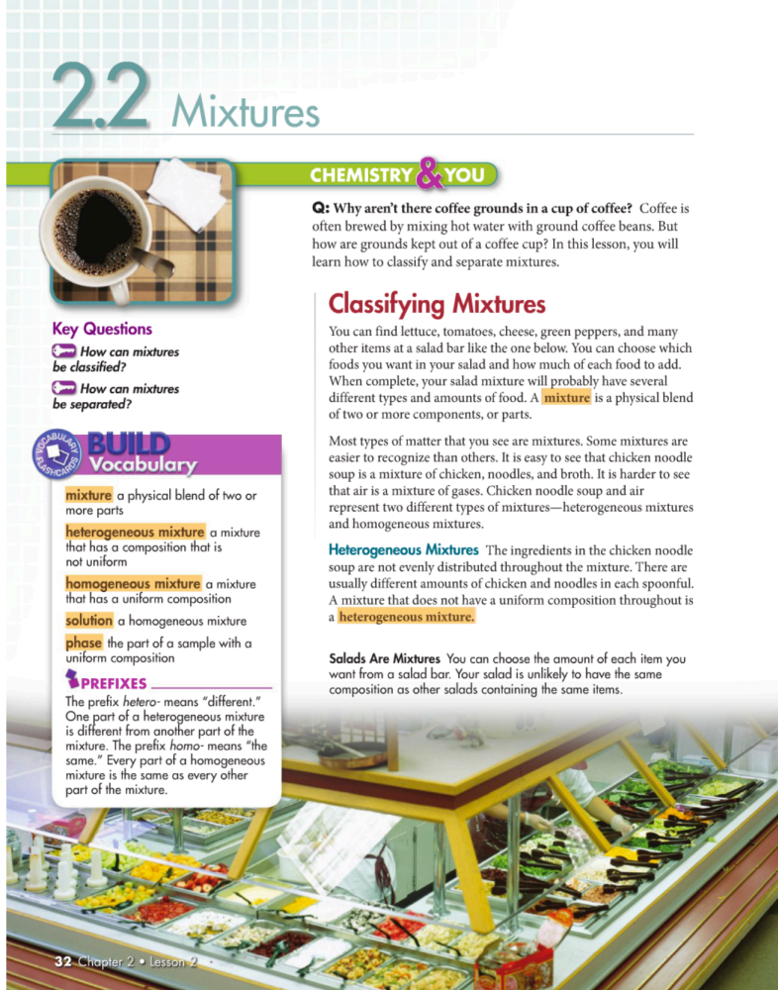
Comprehension Questions:
- What’s the difference between heterogeneous and homogeneous mixtures?

- List one example of a heterogeneous mixture and one example of a homogenous mixture.

- What process is used to separate ground coffee beans from brewed coffee?

- Give 2 examples of mixtures you have separated at home and explain how you separated them.

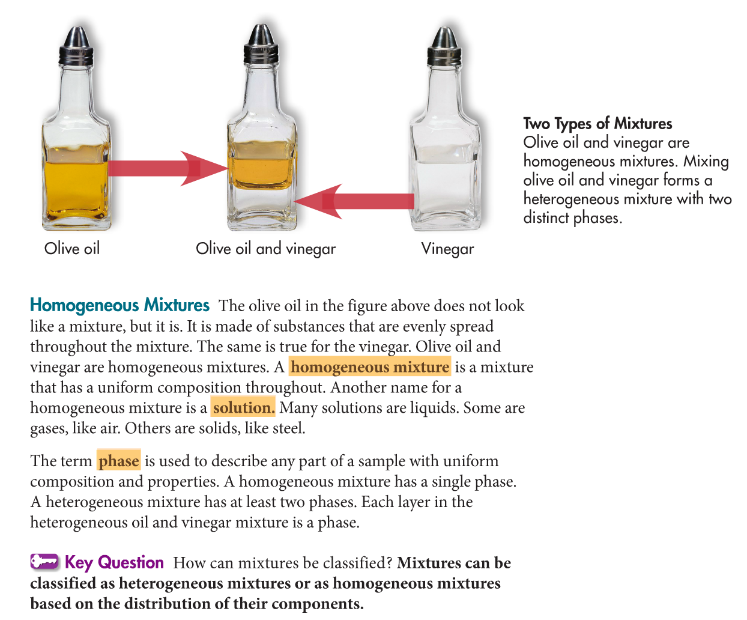
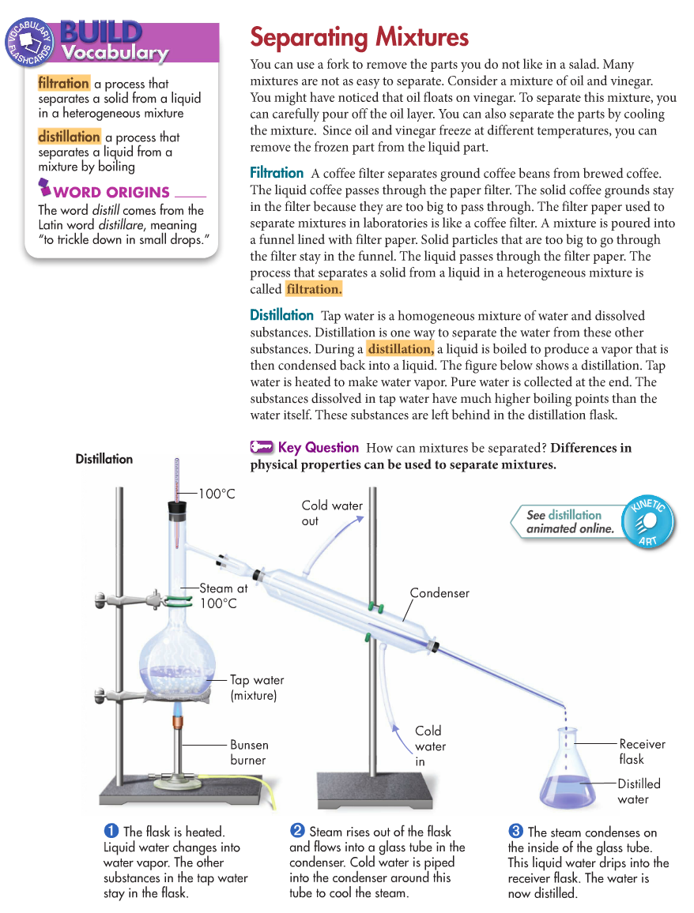

Application Question:
Classify each of the following as a homogeneous or heterogeneous mixture.
  - Chocolate-chip ice cream _______________________
  - Green ink _______________________
  - Cooking oil _______________________
  - Granite rock _______________________
  - Salt water _______________________
  - Paint _______________________

