Name: ______________________________ Period: ________ Date: _______________

Practice Problems: Classifying Matter and Chemical/Physical Properties

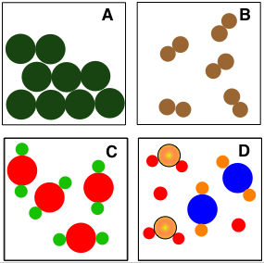
1. Identify the following diagrams as an element, compound, mixture of elements, mixture of compounds, or mixture of elements and compounds.
A. ____________________________________

B. ____________________________________

C. ____________________________________

D. ____________________________________

2. Identify each of the following as an example of a physical property or a chemical property.

- Silver tarnishes when it comes in contact with hydrogen sulfide in the air.

- A banana is yellow.

- A sheet of copper can be pounded into a bowl.

- Barium melts at 725 Celsius.

- Gasoline is flammable.

- A diamond is the hardest natural substance.

- Helium does not react with any other element.

- A bar of lead is more easily bent than is a bar of aluminum of the same size.

- Potassium metal is kept submerged in oil to prevent contact with oxygen or water.

- An apple will turn brown is left in oxygen.

- Diamond dust can be used to cut or grind most other materials.

- Acid in tomato sauce can corrode aluminum foil.

- Rocks containing carbonates can be identified because they fizz when hydrochloric acid is applied.
Name: _____________________________ Period: ________ Date: ________________

Exit Ticket

Choose the word (Physical or Chemical) that best completes each statement below. You can circle both words if the statement applies to both.

- (Physical or Chemical) properties describe matter.
- (Physical or Chemical) properties of a substance can be easily observed.
- You can use your five senses to determine the (Physical or Chemical) properties of a substance.
- (Physical or Chemical) properties usually describe how a substance reacts.
- (Physical or Chemical) properties are not as easy to observe.

Name: _____________________________ Period: ________ Date: ________________

Exit Ticket

Choose the word (Physical or Chemical) that best completes each statement below. You can circle both words if the statement applies to both.

- (Physical or Chemical) properties describe matter.
- (Physical or Chemical) properties of a substance can be easily observed.
- You can use your five senses to determine the (Physical or Chemical) properties of a substance.
- (Physical or Chemical) properties usually describe how a substance reacts.
- (Physical or Chemical) properties are not as easy to observe.

Name: _____________________________ Period: ________ Date: ________________

Exit Ticket

Choose the word (Physical or Chemical) that best completes each statement below. You can circle both words if the statement applies to both.

- (Physical or Chemical) properties describe matter.
- (Physical or Chemical) properties of a substance can be easily observed.
- You can use your five senses to determine the (Physical or Chemical) properties of a substance.
- (Physical or Chemical) properties usually describe how a substance reacts.
- (Physical or Chemical) properties are not as easy to observe.

