Name: _________________________________ Period: _______ Date: _____________
Five MORE Famous Psychological Experiments That Could Never Happen Today
6. ASCH CONFORMITY EXPERIMENTS

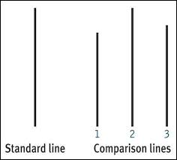
Solomon Asch tested conformity at Swarthmore College in 1951 by putting a participant in a group of people whose task was to match line lengths. Each individual was expected to announce which of three lines was the closest in length to a reference line. But the participant was placed in a group of actors, who were all told to give the correct answer twice then switch to each saying the same incorrect answer. Asch wanted to see whether the participant would conform and start to give the wrong answer as well, knowing that he would otherwise be a single outlier.

Thirty-seven of the 50 participants agreed with the incorrect group despite physical evidence to the contrary. Asch used deception in his experiment without getting informed consent from his participants, so his study could not be replicated today.

7. THE BYSTANDER EFFECT

Some psychological experiments that were designed to test the bystander effect are considered unethical by today’s standards. In 1968, John Darley and Bibb Latané developed an interest in crime witnesses who did not take action. They were particularly intrigued by the murder of Kitty Genovese, a young woman whose murder was witnessed by many, but still not prevented.
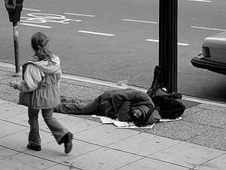
The pair conducted a study at Columbia University in which they would give a participant a survey and leave him alone in a room to fill out the paper. Harmless smoke would start to seep into the room after a short amount of time. The study showed that the solo participant was much faster to report the smoke than participants who had the exact same experience, but were in a group.

The studies became progressively unethical by putting participants at risk of psychological harm. Darley and Latané played a recording of an actor pretending to have a seizure in the headphones of a person, who believed he or she was listening to an actual medical emergency that was taking place down the hall. Again, participants were much quicker to react when they thought they were the sole person who could hear the seizure.

8. LEARNED HELPLESSNESS

The ethics of Martin Seligman’s experiments on learned helplessness would also be called into question today due to his mistreatment of animals. In 1965, Seligman and his team used dogs as subjects to test how one might perceive control. The group would place a dog on one side of a box that was divided in half by a low barrier. Then they would administer a shock, which was avoidable if the dog jumped over the barrier to the other half. Dogs quickly learned how to prevent themselves from being shocked.
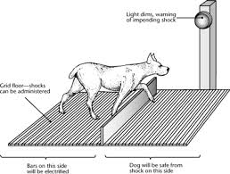
Seligman’s group then harnessed a group of dogs and randomly administered shocks, which were completely unavoidable. The next day, these dogs were placed in the box with the barrier. Despite new circumstances that would have allowed them to escape the painful shocks, these dogs did not even try to jump over the barrier; they only cried and did not jump at all, demonstrating learned helplessness.

9. ROBBERS CAVE EXPERIMENT

Muzafer Sherif conducted the Robbers Cave Experiment in the summer of 1954, testing group dynamics in the face of conflict. A group of preteen boys were brought to a summer camp, but they did not know that the counselors were actually psychological researchers. The boys were split into two groups, which were kept very separate. The groups only came into contact with each other when they were competing in sporting events or other activities.

The experimenters orchestrated increased tension between the two groups, particularly by keeping competitions close in points. Then, Sherif created problems, such as a water shortage, that would require both teams to unite and work together in order to achieve a goal. After a few of these, the groups became completely undivided and amicable.

Though the experiment seems simple and perhaps harmless, it would still be considered unethical today because Sherif used deception as the boys did not know they were participating in a psychological experiment. Sherif also did not have informed consent from participants.

10. BLUE EYED VERSUS BROWN EYED STUDENTS

Jane Elliott was not a psychologist, but she developed one of the most famously controversial exercises in 1968 by dividing students into a blue-eyed group and a brown-eyed group. Elliott was an elementary school teacher in Iowa, who was trying to give her students hands-on experience with discrimination the day after Martin Luther King Jr. was shot, but this exercise still has significance to psychology today. The famous exercise even transformed Elliott’s career into one centered around diversity training.

After dividing the class into groups, Elliott would cite phony scientific research claiming that one group was superior to the other. Throughout the day, the group would be treated as such. Elliott learned that it only took a day for the “superior” group to turn crueler and the “inferior” group to become more insecure. The blue eyed and brown eyed groups then switched so that all students endured the same prejudices.

Elliott’s exercise (which she repeated in 1969 and 1970) received plenty of public backlash, which is probably why it would not be replicated in a psychological experiment or classroom today. The main ethical concerns would be with deception and consent, though some of the original participants still regard the experiment as life-changing.

Name of Experiment
Experimenter
Subject(s)
Experimental question
Conclusions
Unethical components
Directions: Choose 4 of the 5 unethical experiments to summarize.
Name of Experiment
Experimenter
Subject(s)
Experimental question
Conclusions
Unethical components

