Name: __________________________________________ Period: ___________ Date: _____________

Lab Safety Equipment

Name | When To Use It | How To Use It | Additional Notes
Eyewash
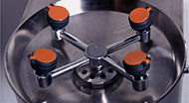
Fire blanket
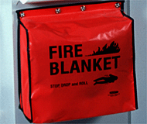
Fume hood
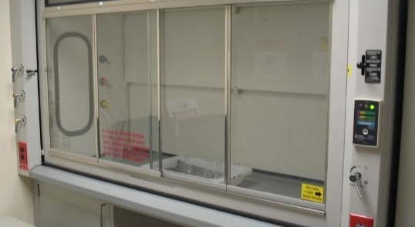
Safety shower
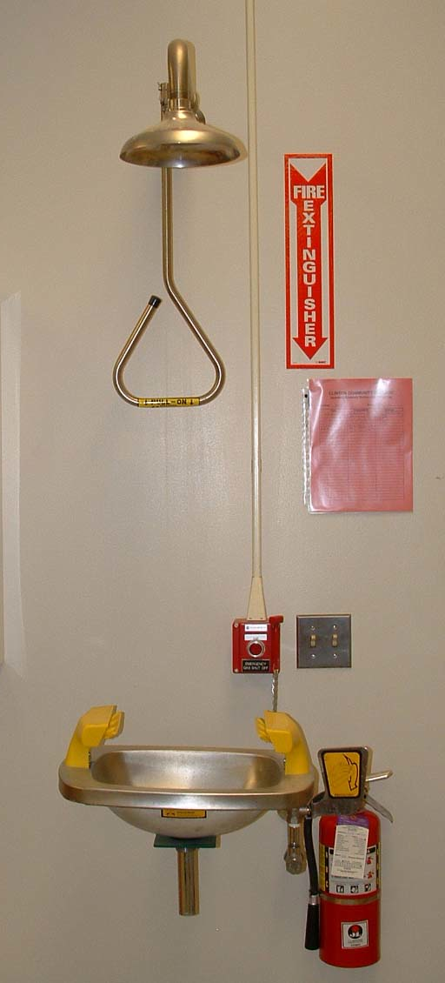
Fire extinguisher
