Name: _________________________________ Period: _______ Date: _____________

Unit 2 Quiz INFO and PRACTICE

Standards  - Use physical and chemical properties to distinguish one substance from another or identify an unknown substance  - Explain the three states of matter (solid, liquid, gas) in terms of the structure, properties, and interactions of their particles | Objectives  - Classify matter as a pure substance (element or compound) or mixture (homogenous or heterogeneous)  - Compare and contrast chemical and physical properties  - Compare and contrast chemical and physical changes  - Define and identify states of matter and draw particle diagrams describing states of matter

1. Match the following vocabulary words to their definitions

___physical change

___chemical change

___liquid

___solid

___gas

- a change that does not change the composition of a substance
- flowing, compressible matter with no definite volume or shape
- flowing matter with definite volume but indefinite shape
- involves the change of one or more substances into other substances
- rigid with a definite shape
2. Classify each of the diagrams below by placing the correct label in the blanks below:

1 = element
2 = compound
3 = mixture
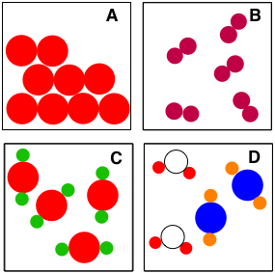
A = _______________________
B = _______________________
C = _______________________
D = _______________________

3. Classify the following. First, classify as “pure substance” or “mixture”. Then, classify further as “homogenous”, “heterogeneous”, “element”, or “compound.”
Substance | Pure Substance or Mixture? | Element, Compound, Heterogeneous or Homogeneous?
Blood
Tea with tea leaves floating in it
Calcium Chloride (CaCl₂)
Calcium (Ca)

4. Classify the following properties as either chemical or physical by putting a check in the appropriate column.
 | Physical Property | Chemical Property
11. Blue Color
12. Reacts with Acid to form a gas
13. Sour taste
14. Melting Point
15. Reacts with base to form water
16. Density

5. Classify the following change as being a physical change or a chemical change by putting a check in the appropriate column.
 | Physical Property | Chemical Property
16. Salt dissolves in water
17. Water is heated and changed into steam
18. Iron rusts
19. Food is digested in the stomach
20. Ice melting

6. Indicate if the following properties are characteristic of liquids, solids, or gases.

____________fixed shape
____________indefinite volume
____________pourable
____________fast-moving particles

