Acetylcholine (ACh)

Acetylcholine (often abbreviated ACh) is the most common neurotransmitter. It is located in both the central nervous system (CNS) and the peripheral nervous system (PNS).
Acetylcholine was the first neurotransmitter to be identified. It was discovered by Henry Hallett Dale in 1914, and its existence was later confirmed by Otto Loewi. Both individuals were awarded the Nobel Prize in Physiology/Medicine in 1936 for their discovery.

In the body, acetylcholine is the primary neurotransmitter that nerves use to signal muscles to initiate or cease movement. Botulinism toxin, the substance that causes botulism, works by preventing the release of acetylcholine in the body; this can paralyze respiratory muscles, causing suffocation and death. The venom of the black widow spider causes an equally lethal overrelease of acetylcholine -- flooding the system.
In the brain, acetylcholine is produced in several locations including the basal forebrain. It may promote learning. Acetylcholine-producing cells in the basal forebrain are damaged in the early stages of Alzheimer's disease, which may contribute to the memory impairments that are an early symptom of the disease. The drugs tacrine (brand name Cognex) and donepezil (trade name Aricept), currently marketed as Alzheimer's drugs, are cholinesterase inhibitors, meaning that they increase the effectiveness of acetylcholine in the brain.
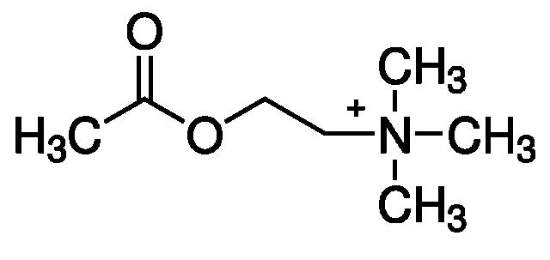

Dopamine (DA)

Role in Movement
Dopamine plays a critical role in the way our brain controls our movements. Thus, shortage of dopamine, particularly the death of dopamine neurons in the nigrostriatal pathway, is a cause of Parkinson's disease, in which a person loses the ability to execute smooth, controlled movements.
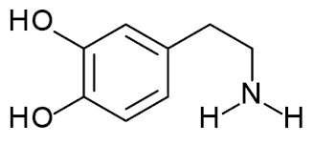

Role in Pleasure and Motivation
Dopamine is commonly associated with the 'pleasure system' of the brain, providing feelings of enjoyment and reinforcement to motivate us to do, or continue doing, certain activities. Dopamine is released by naturally rewarding experiences such as food, sex, abuse of drugs, and neutral stimuli that become associated with them. This theory is often discussed in terms of drugs (such as cocaine), which seem to directly produce dopamine release in these areas, and in relation to neurobiological theories of addiction, which argue that these dopamine pathways are pathologically altered in addicted persons.
Other theories suggest that the crucial role of dopamine may be in predicting pleasurable activity. Related theories argue that dopamine function may be involved in the salience ('noticeableness') of perceived objects and events, with potentially important stimuli (including rewarding things, but also things which may be dangerous or a threat) appearing more noticeable or more important. This theory argues that dopamine's role is to assist decision-making by influencing the priority of such stimuli to the person concerned.

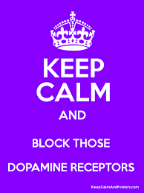
Dopamine and Psychosis
Disruption to the dopamine system has also been strongly linked to psychosis and schizophrenia. Dopamine neurons in the mesolimbic pathway are particularly associated with these conditions. This is partly due to the discovery of a class of drugs called the phenothiazines (which block D2 dopamine receptors), which can reduce psychotic symptoms, and partly due to the finding that drugs such as amphetamine and cocaine (which are known to greatly increase dopamine levels) can cause psychosis when used in excess. Because of this, all modern antipsychotic medication is designed to block dopamine function to varying degrees.
Serotonin (5-HT)

What does Serotonin do?
Serotonin is believed to play an important part of the biochemistry of depression, bipolar disorder and anxiety. It is also believed to be influential on sexuality.
Serotonin taken orally is not passed into the serotonin pathways of the brain. Since it is such an important regulating chemical, the blood-brain barrier prevents serotonin in the blood stream from directly affecting serotonin levels in the brain. However, the amino acid tryptophan and its metabolite 5-hydroxytryptophan, which serotonin is synthesized from, are capable of crossing the blood-brain barrier. These chemicals are readily available as dietary supplements and may be effective serotonergic agents.
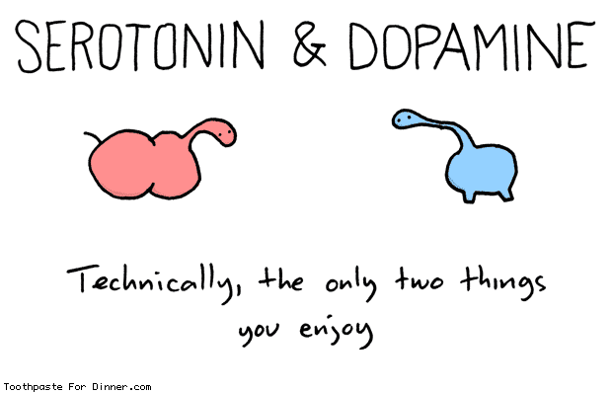
Other ways of working around the blood-brain barrier include a variety of psychiatric medications that affect serotonin levels indirectly, including MAO inhibitors, tricyclic antidepressants, and SSRIs. The last category includes the well-known antidepressant Prozac.

How Antidepressants Work
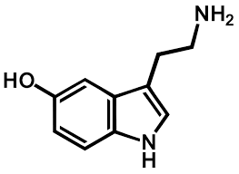
After serotonin is released by a neuron it activates receptors located on adjacent neurons. Serotonin can be taken up again by the neuron that released it, sometimes for reuse. Some drugs inhibit this re-uptake of serotonin, again making it stay in the synapse longer. The tricyclic antidepressants inhibit the re-uptake of both serotonin and norepinephrine. The newer Selective Serotonin Re-uptake Inhibitors (SSRIs) have fewer (though still numerous) side effects and fewer interactions with other drugs.
Serotonin is found extensively in the human gut, as well as in the blood stream.

Norepinephrine
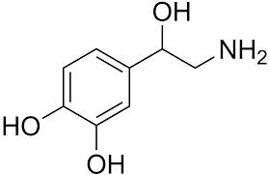
Norepinephrine (NE) is the neurotransmitter often associated with the “fight or flight” response to stress. Strongly linked to physical responses and reactions, it can increase heart rate and blood pressure as well as create a sense of panic and overwhelming fear/dread. Emotionally, anxiety and depression are related to norepinephrine levels in the brain, as this neurotransmitter seems to maintain the balance between agitation and depression.
Low levels of norepinephrine are associated with a loss of alertness, poor memory, and depression. Norepinephrine appears to be the neurotransmitter of “arousal” and for that reason, lower-than-normal levels of this neurotransmitter produce below-average levels of arousal and interest, a symptom found in several psychiatric conditions including depression and ADHD. It is for this reason that medications for depression and ADHD often target both dopamine and norepinephrine in an attempt to restore both to normal level.
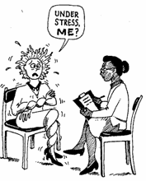
Moderately high levels of norepinephrine create a sense of arousal that becomes uncomfortable. Remembering that this neurotransmitter is strongly involved in creating physical reactions, moderate increases create worry, anxiety, increased startle reflex, jumpiness, fears of crowds & tight places, impaired concentration, restless sleep, and physical changes. The physical symptoms may include rapid fatigue, muscle tension/cramps, irritability, and a sense of being on edge. Almost all anxiety disorders involve norepinephrine elevations. Severe and sudden increases in norepinephrine are associated with panic attacks.

GABA and glutamate are neurotransmitters -- chemical messengers in your brain. One is calming, one is stimulating, and they're supposed to stay in balance with each other. So what happens if this balance is thrown off?
Some research suggests an imbalance of these two substances may play a role infibromyalgia (FMS). Research is less solid on their involvement in chronic fatigue syndrome (ME/CFS), with some studies turning up evidence of dysregulation and others finding nothing.

In Your Brain
The human brain is incredibly complex. Each neurotransmitter performs a variety of functions, and they interact with each other and your neurons (brain cells) in an intricate manner that we don't fully understand.
Still, we're constantly learning more about the brain and researchers have been able to link certain neurotransmitter abnormalities to certain illnesses or symptoms. They've also found ways to manipulate neurotransmitter function and see the very real effects it has on research subjects.
The brain is an efficient recycler, often using one neurotransmitter to create another. This function makes a lot of sense when you're talking about neurotransmitters with opposite functions, such as GABA and glutamate, or the better-known serotoninand melatonin.

Glutamate
A primary function of glutamate is to get brain cells fired up. It stimulates them so they can do important things like learning new information or forming memories - other things in which glutamate is involved.
However, too much of a stimulant isn't a good thing, as anyone who's drunk way too much coffee can tell you. Glutamate can become what's called an "exitotoxin," meaning that it appears to excite neurons until they die. Glutamate is believed to be involved in some degenerative brain diseases such as Alzheimer's disease and amyotrophic lateral sclerosis (ALS or Lou Gherig's disease.) (Note: FMS and ME/CFS are NOT believed to be degenerative.)
In FMS, research shows abnormally high levels of glutamate in a part of the brain called the insula or insular cortex. Researchers went looking there because that area is highly involved in pain and emotion, which are key components of the condition. The insula is also involved in sensory perception, motor skills, anxiety,eating disorders and addiction.
Research also has linked high glutamate levels with depression and low cognitive function in people with type 1 diabetes. (Glutamate can be derived glucose, which is often high in diabetics.) At least one FMS study has suggested that lowering glutamate levels can reduce pain.
Excess brain glutamate is believed to cause symptoms including:
- Hyperalgesia (pain amplification)
- Anxiety
- Restlessness
- ADHD-like symptoms, such as inability to focus
In ME/CFS, some researchers hypothesize that glutamate function is low, which means the brain isn't getting enough stimulation. However, this belief is not yet supported by evidence.
A glutamate deficiency in the brain is believed to cause symptoms including:
- Insomnia
- Concentration problems
- Mental exhaustion
- Low energy

GABA
GABA stands for gamma-amino-n-butyric acid. Your brain uses glutamate to produce GABA.
A primary function of GABA is to calm your brain. It's also involved in sleep, relaxation, anxiety regulation and muscle function.
Thus far, research does not suggest GABA dysregulation in ME/CFS.
Because of GABA and glutamate's close relationship, symptoms of brain GABA deficiency may resemble, or overlap with, those of brain glutamate excess.

Norepinephrine is a neurotransmitter that is secreted in response to stress. Learn about what norepinephrine is and how it affects the body. Additionally, discover what drug contains norepinephrine and if it is safe to use.

Definition
Have you ever wondered why your heart beats faster and your palms get sweaty when you're scared? Those are both caused by the release of norepinephrine in your body.
Norepinephrine is a chemical released from the sympathetic nervous system in response to stress. It is classified as a neurotransmitter, a chemical that is released from neurons. Because the release of norepinephrine affects other organs of the body, it is also referred to as a stress hormone.
The sympathetic nervous system triggers a response that is commonly referred to as our 'fight or flight response.' When we are faced with a situation that is potentially dangerous, we need to make a decision to either stay and face whatever we find intimidating or scary or to turn and run away as fast as we can! Both of these options require our body to work faster and better. This is where norepinephrine comes in.

Function
In order to make our body work as efficiently as possible, norepinephrine causes several changes in our body function. These include the following:
- An increase in the amount of oxygen going to our brain - this helps us think clearer and faster.
- An increase in our heart rate - this pumps more blood around our body, helping our muscles work faster and more efficiently.
- An increase in glucose (or sugar) release - this additional sugar gives our muscles something to 'feed on,' which helps them work better and faster.
- An increase in breathing rate - when we breathe faster, we are delivering more oxygen to the body and brain. This helps our entire body work better.
- A shutting down of metabolic processes - shutting down processes, like digestion and growth, allows blood and energy that would normally go to these functions to be shunted to our muscles and brain.

Norepinephrine
Norepinephrine (NE) is the neurotransmitter often associated with the “fight or flight” response to stress. Strongly linked to physical responses and reactions, it can increase heart rate and blood pressure as well as create a sense of panic and overwhelming fear/dread. Emotionally, anxiety and depression are related to norepinephrine levels in the brain, as this neurotransmitter seems to maintain the balance between agitation and depression.
Low levels of norepinephrine are associated with a loss of alertness, poor memory, and depression. Norepinephrine appears to be the neurotransmitter of “arousal” and for that reason, lower-than-normal levels of this neurotransmitter produce below-average levels of arousal and interest, a symptom found in several psychiatric conditions including depression and ADHD. It is for this reason that medications for depression and ADHD often target both dopamine and norepinephrine in an attempt to restore both to normal level.
Moderately high levels of norepinephrine create a sense of arousal that becomes uncomfortable. Remembering that this neurotransmitter is strongly involved in creating physical reactions, moderate increases create worry, anxiety, increased startle reflex, jumpiness, fears of crowds & tight places, impaired concentration, restless sleep, and physical changes. The physical symptoms may include rapid fatigue, muscle tension/cramps, irritability, and a sense of being on edge. Almost all anxiety disorders involve norepinephrine elevations. Severe and sudden increases in norepinephrine are associated with panic attacks.

Glutamate Could glutamate excitotoxicity be a key player in chronic fatigue syndrome? Glutamate plays a beneficial and indeed crucial role as the primary excitatory neurotransmitter powering the transmission of messages between neurons. Without glutamate we’d be unable to respond quickly to events but too much glutamate can lead to a condition called excitotoxicity which can damage or destroy neurons. “Excitotoxicity is the pathological process by which nerve cells are damaged and killed by excessive stimulation by neurotransmitters such as glutamate…. This occurs when receptors receptors for the excitatory neurotransmitter such as the NMDA and AMPA receptors are overactivated.” Wikipedia Interestingly, given the low blood flow problems in chronic fatigue syndrome, central nervous system ischemia (low blood flows) increases glutamate levels and contributes to cellular death. High glutamate levels shift the central nervous system towards seizure, and indeed, researchers have known for over 50 years that directly applying glutamate to the central nervous system causes seizures. Dr. Paul Cheney has long proposed that a shift towards seizure brought on by overstimulated, overly sensitive neurons explains the ‘wired but tired’ symptoms and sensory overload often experienced in ME/CFS. “Our neurons (nerve cells) are sensing stimuli and firing when they should not. This causes amplification of sensory input. Light, noise, motion and pain are all magnified. At the beginning of their illness, many patients report feeling exhausted, yet also strangely “wired.” The “wired” feeling is the slight shift towards seizure that occurs as a result of the excitatory neurotoxicity.” From Carol Sieverlings reports Cheney proposed that overly activated NMDA (glutamate) receptors cause neurons to fire at the slightest stimulation. He suggested people with ME/CFS use Klonopin, Doxepin elixir and magnesium to reduce receptor activation and indeed Klonopin is widely used in ME/CFS. Normally glutamate is balanced by the inhibitory neurotransmitter GABA. It is likely that the balance between glutamate and GABA may determine the excitatory/inhibitory balance in the central nervous system and hence the ratio of ‘signal’ to ‘noise’. It seems logical that an excess of glutamate might result in increased noise and a deficit in signal gating leading to various ‘overload phenomena’.

